Assignment 35.2

Problem Statement:

● Explain and perform Sqoop Incremental Import operation to load data from Mysql To HDFS using Sqoop

● Explain the procedures performed, Share the screenshots of commands and results for the same.

Contents in the table employee in Mysql are displayed and 3 new records are inserted in it.

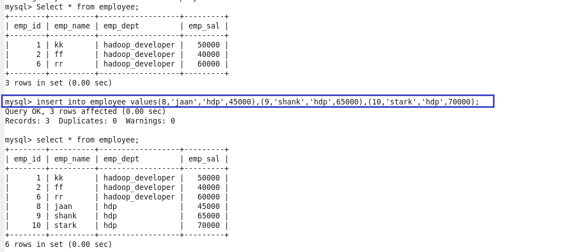

The following syntax is used for the incremental option in Sqoop import command.

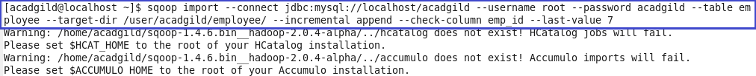

This shows that part file has been created in the target directory. Now, following command is used to view the content inside part file.

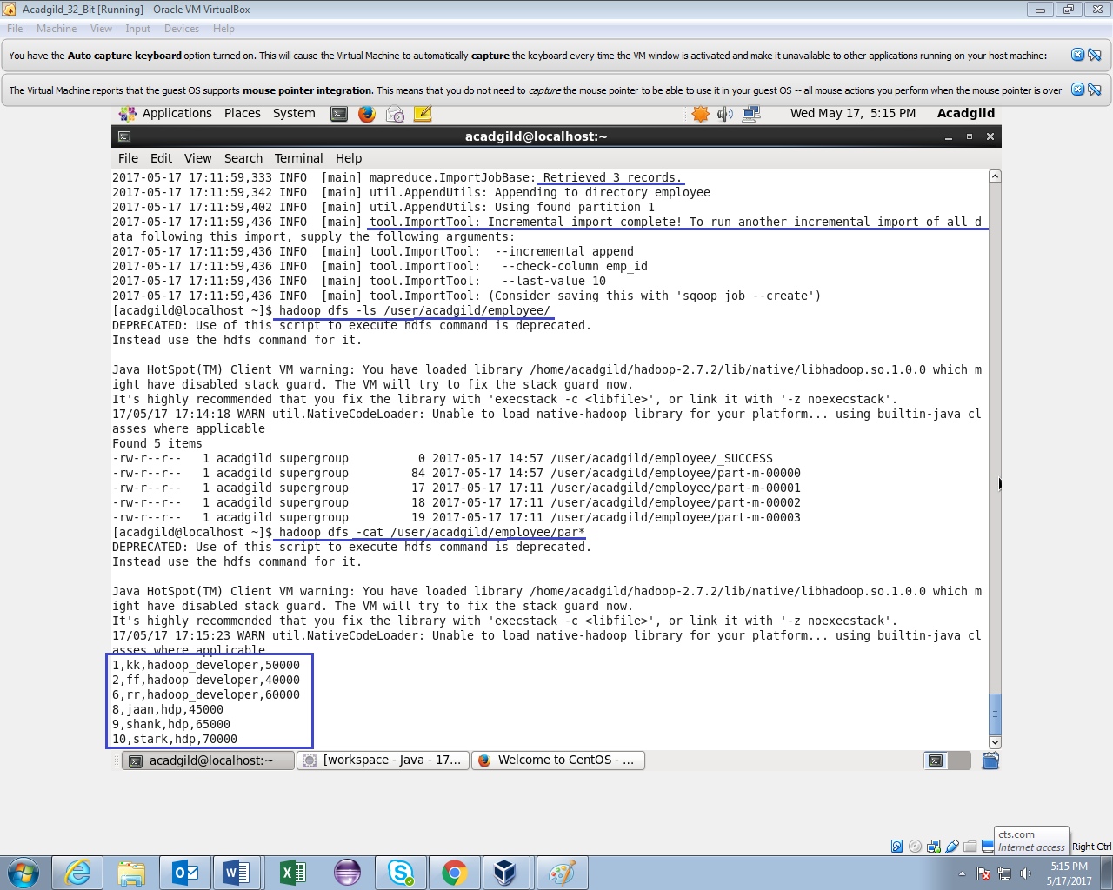

This is how incremental import is done every time for any number of new rows.